Sample Path Following Robot Instructions
Operation: [Required]
To operate the Path Following robot perform the following steps.
- Place the poster with the map the robot will follow on the floor with the line facing up
- Position the robot at the location marked start
  - The wheels of the robot will line up with blue boxes on either side of the word “START”
  - The front of the robot has a gray rectangle that will line up with the dark line
  - The back of the robot will sit on a red line
- Press the dark gray rectangular button on the front of the robot under the display screen
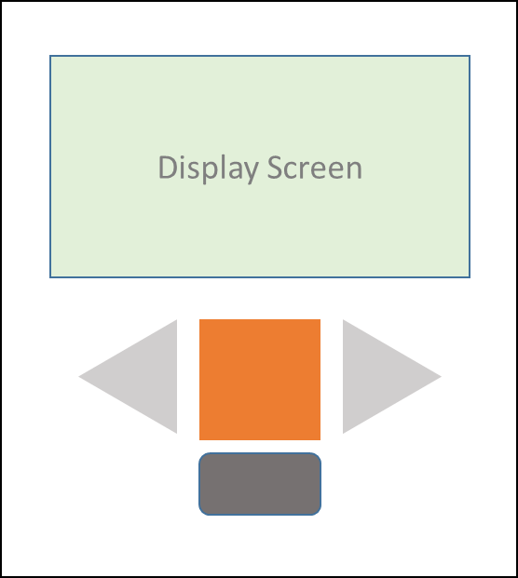
- Wait for the robot to finish loading, when done the display screen will show a list of files
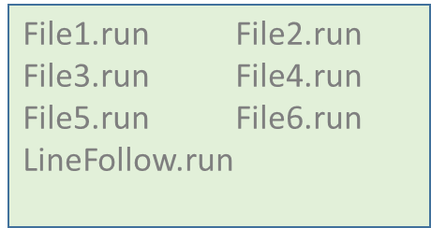
- Use the left and right arrow buttons on the front of the robot to highlight the file “LineFollow.run”
- Press the orange button on the front of the robot to start the line follow program
- Watch as the robot moves forward and begins to follow the line, it will progress all the way to the finish line (red line with the word FINISH behind it)
See other side for how to shut down the robot.
Shut down: [Required]
Once the robot has completed its task be sure to turn off the robot.
- Press the dark gray rectangle button on the front of the robot 2 times
- The display screen will ask “do you want to shut down?”
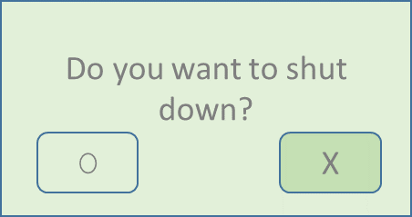
- Use the left arrow to highlight the O box
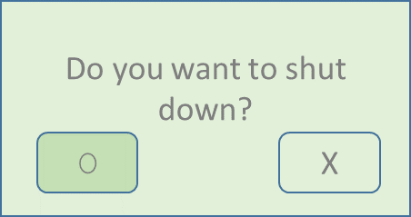
- Press the orange square button to confirm
- The robot will shut down and the display screen will go blank
- Place the robot on the shelf to use again
- Roll up the poster
Troubleshooting: [Optional]
Robot spins around and does not follow the line.
Make sure the gray sensor is on the black line, if it is not the robot is searching for the black line.
Screen does not display when pressing the dark gray button to turn on the robot
Check batteries

Sample notes: Operation and shutdown of the robot are required parts of instructions. The judges need to know how to set it up, operate it, and put the robot up so it can be displayed.
The troubleshooting section isn’t required but is nice to have if there are common problems that may keep a robot from completing its task.
The instructions can be short for simple robots: example 1. Turn switch on 2. Let robot dust 3. Turn switch off. The important thing is someone (like a grandparent) who doesn’t know how to use the robot is able to follow the instructions and operate the robot.
Pictures are not required in the instructions and are only shown as one way to help make the instructions clearer. The pictures were created using PowerPoint and then pasted into the instructions as images.

